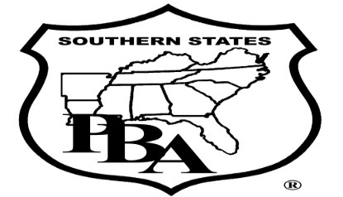

The Center for Security Policy, The Southern States Police Benevolent Association, and The Madison Police Department are hosting an 8-hour training event titled ISIS, the Muslim Brotherhood, & Islamist Ideology: How They Challenge Local Law Enforcement on 02/20/2017 from 8am to 5pm. The training will be held at the Cahaba Shrine 1226 Blake Bottom Rd NW, Huntsville, AL 35806. 8hrs of CEU’s will be awarded at the end of the training. There is no cost to attend.
The training in this 8-hour program presents information on how to distinguish between the protected religious pillars of Islam from the non-protected practices of ISIS and other violent Islamists and how to distinguish between peaceful Muslims from those who want to subvert our Constitution through the activities of the Muslim Brotherhood. Attendees will learn about the conflicting messages of Islamic theology; the historical roots of its foundation; the meaning of jihad; and the major elements of Sharia law. The course covers:
--Objectives and operational plan of the Muslim Brotherhood within the US;
--Cultural and Psychological factors that influence Islamic aggression;
--Roles that mosque’s play in the radicalization of independent terrorists;
--The four phase radicalization process of so called domestic “lone wolves;”
--Local law enforcement response measures to Islamic political and violent extremism.
The course is being taught by David R. Bores (678)780-0298 or drbores05@gmail.com: he has been in public service for over 45 years to include retiring from the Army at the rank of lieutenant colonel, Chief of Police of Woodstock, GA, and Major with the Cherokee County Sheriff’s Office.
To register for the class please send an email to policetraining101@gmail.com. A return email will be sent within 48 hours confirming the registration. Multiple registrations can be submitted in one email.
Points of contact for this training:
Det. Wesley Grigsby 256-603-9936
Officer Teresa Taylor-Duncan 256-759-3970

